**only_Harris_Corner_Detection**

Размытие и блюр

(window_size,harris_parameter,sobel_aperture,threshold)

13 0 3 2

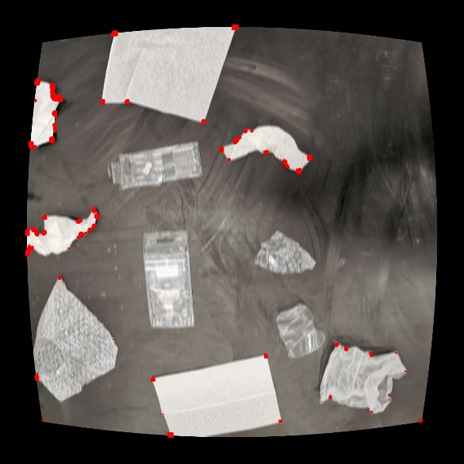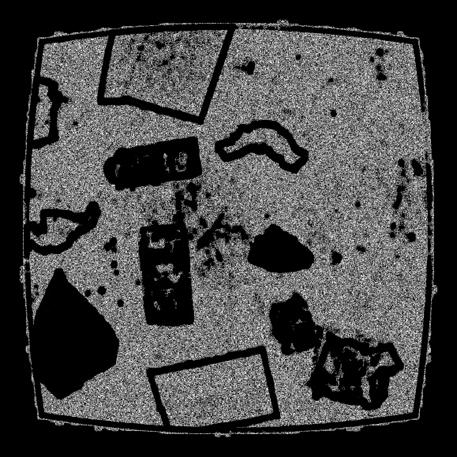

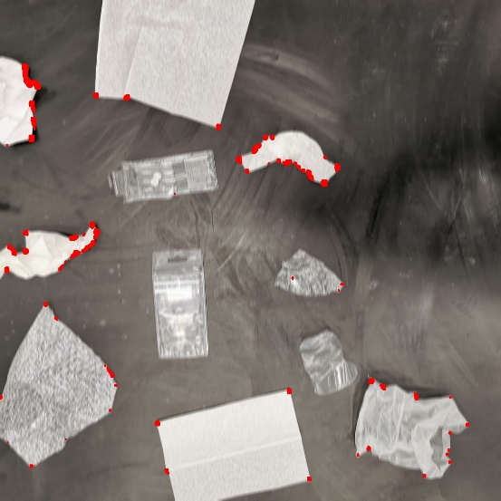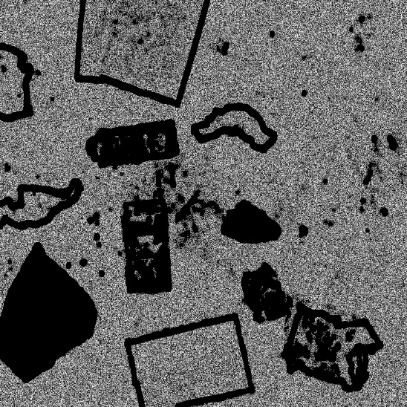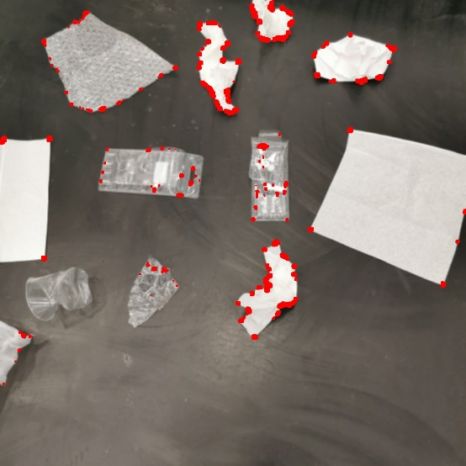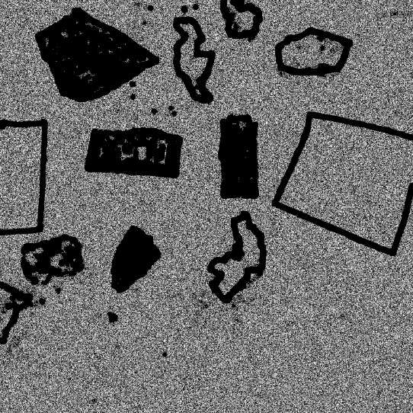

Бумага

9 3 3 2

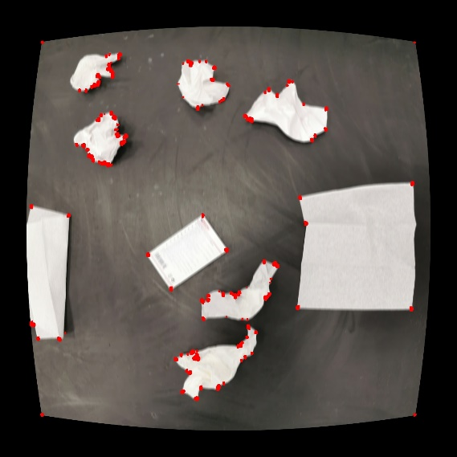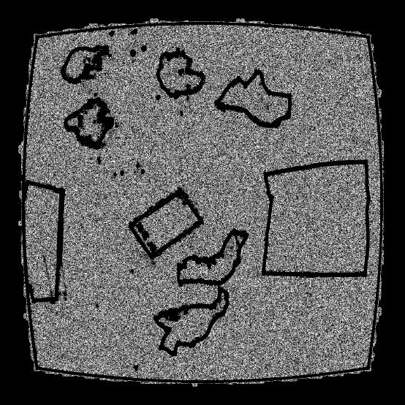

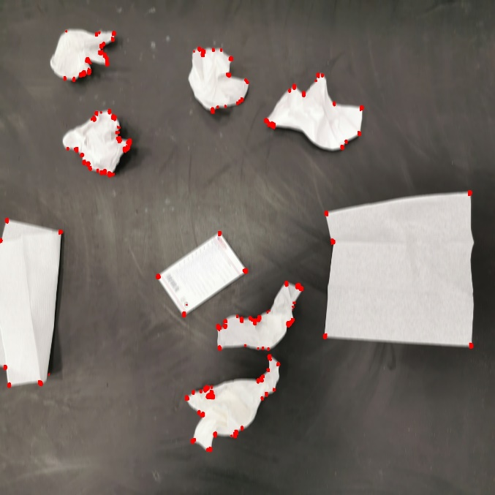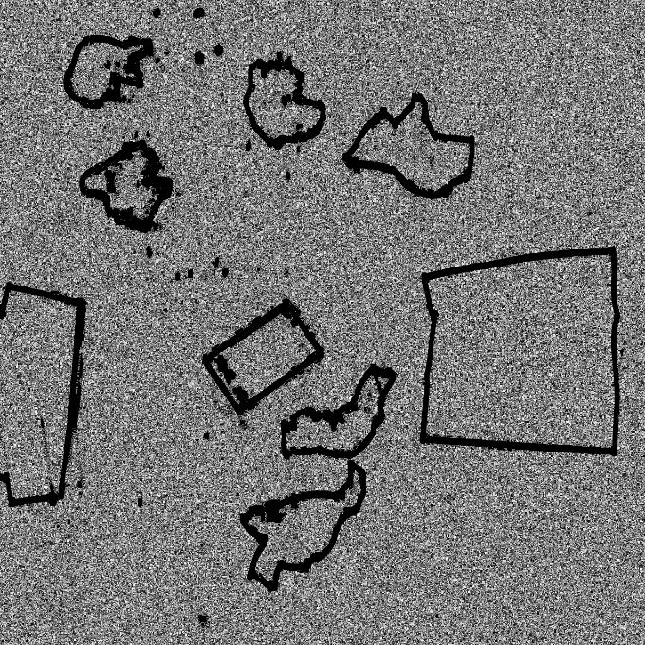

Пластик

9 1 3 3

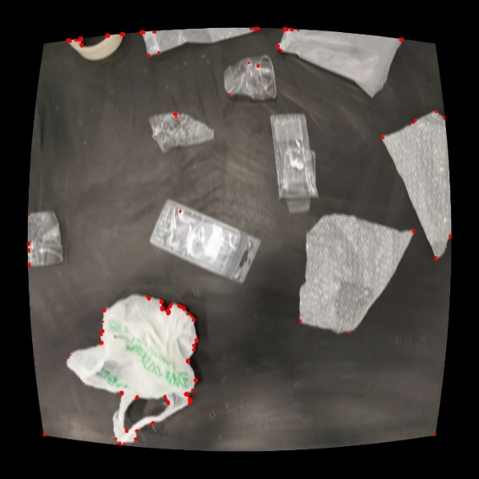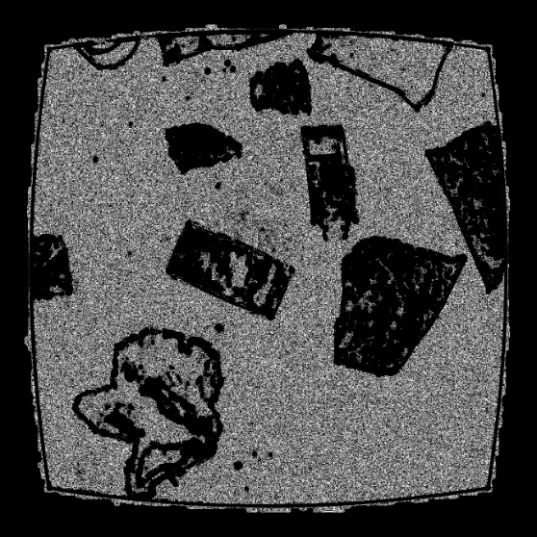

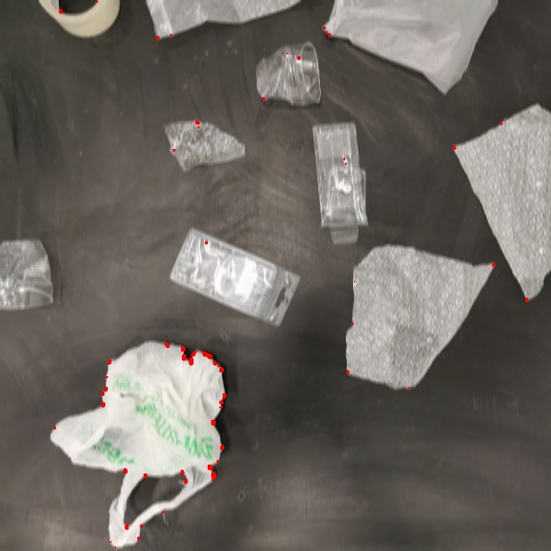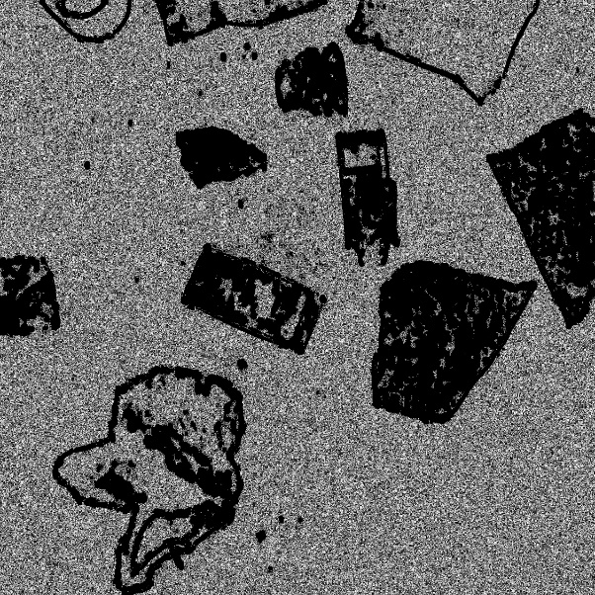

7 5 1 3 – шум

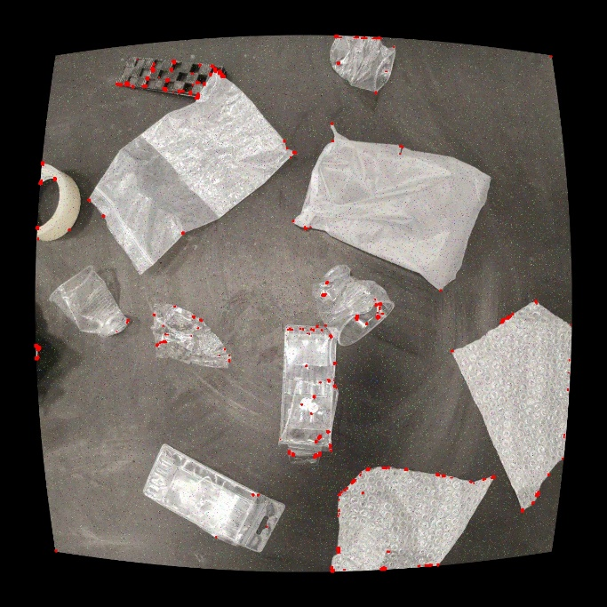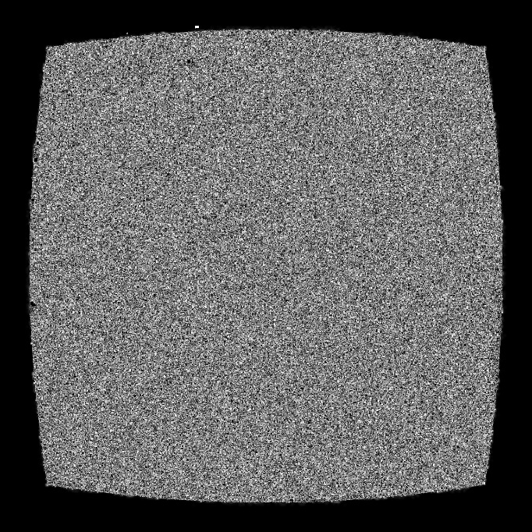

**FAST algorithm for corner detection**

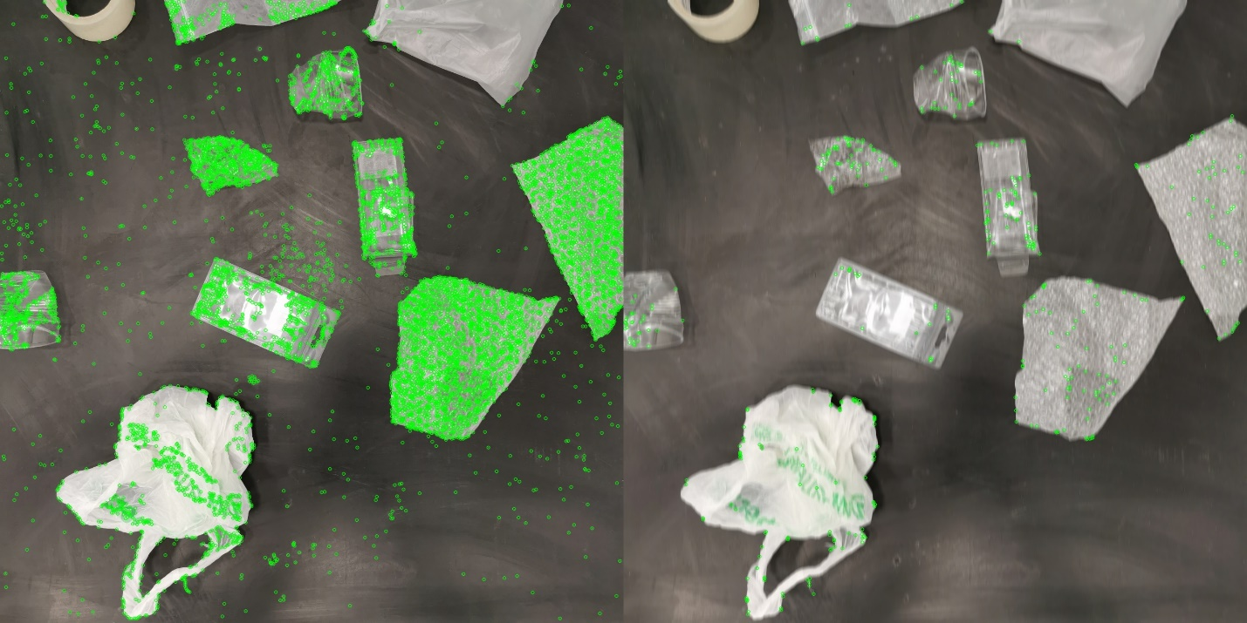

Total Keypoints with nonmaxSuppression: 457

Total Keypoints with nonmaxSuppression original image: 8536

Threshold: 20

nonmaxSuppression: True

neighborhood: 2

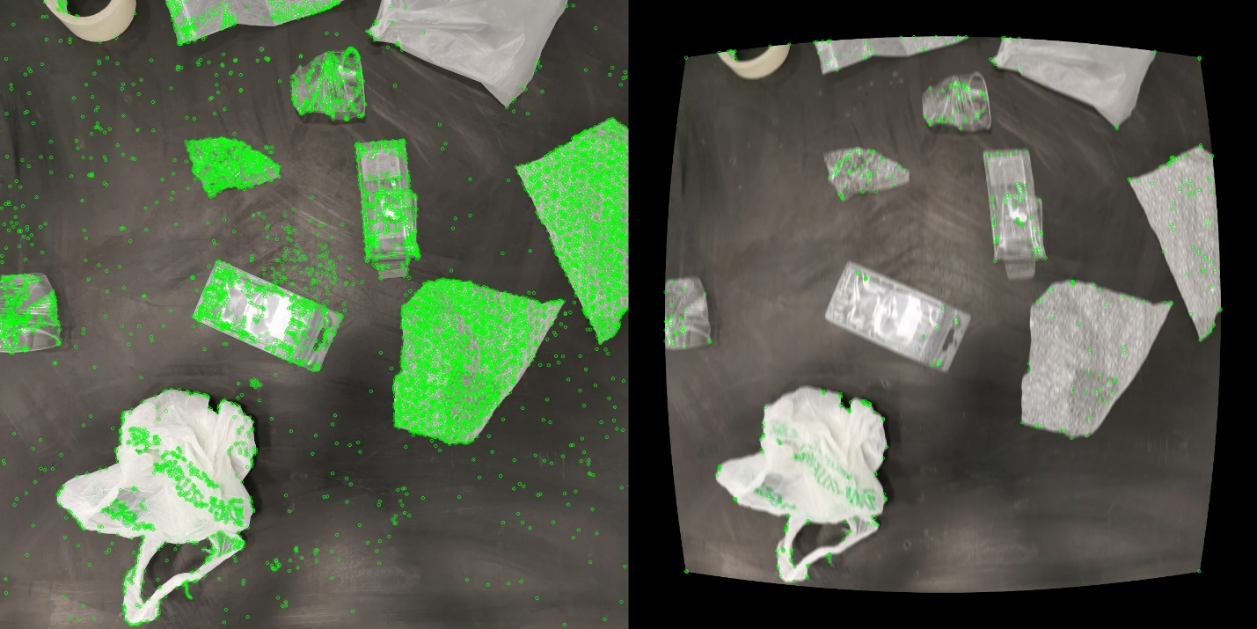

Total Keypoints with nonmaxSuppression: 447

Total Keypoints with nonmaxSuppression original image: 8536

Threshold: 20

nonmaxSuppression: True

neighborhood: 2

**ORB (Oriented FAST and Rotated Brief)**

**Brute-Force Matching with ORB Descriptors**

Total Keypoints with nonmaxSuppression: 2000

Total Keypoints with nonmaxSuppression original image: 2000

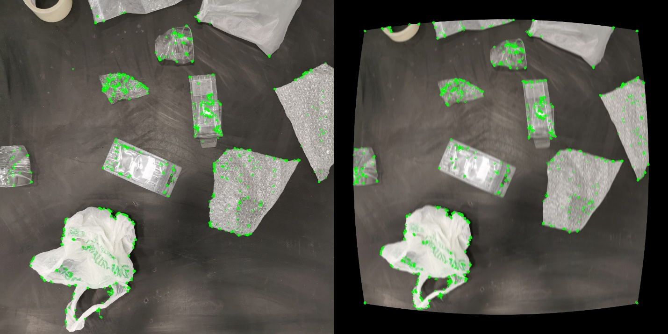

The output image shows the first/top fifteen best feature matching using Brute Force Matcher. Здесь первые 15 лучших совпадений

Total Keypoints with nonmaxSuppression: 1280

Total Keypoints with nonmaxSuppression original image: 1280

Total Number of Features matches found are 792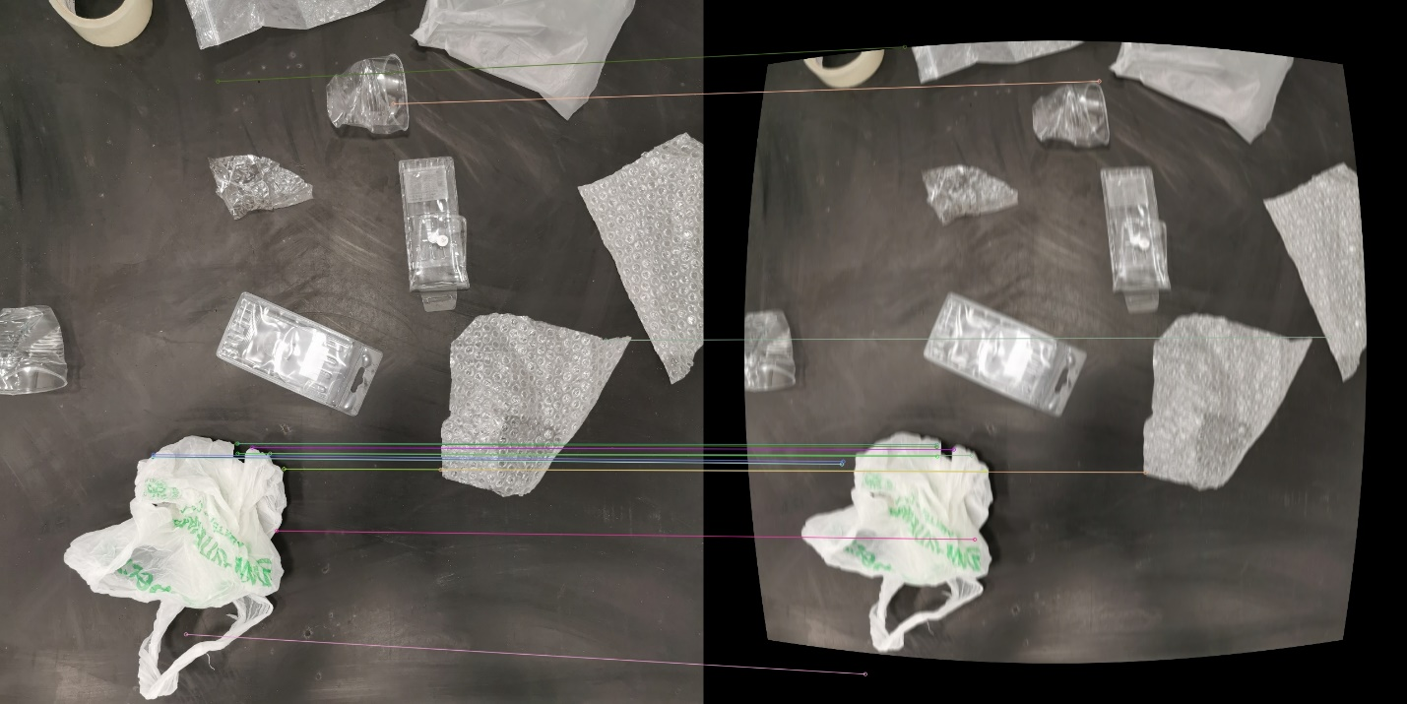

Total Keypoints with nonmaxSuppression: 1280

Total Keypoints with nonmaxSuppression original image: 1280

Total Number of Features matches found are 891

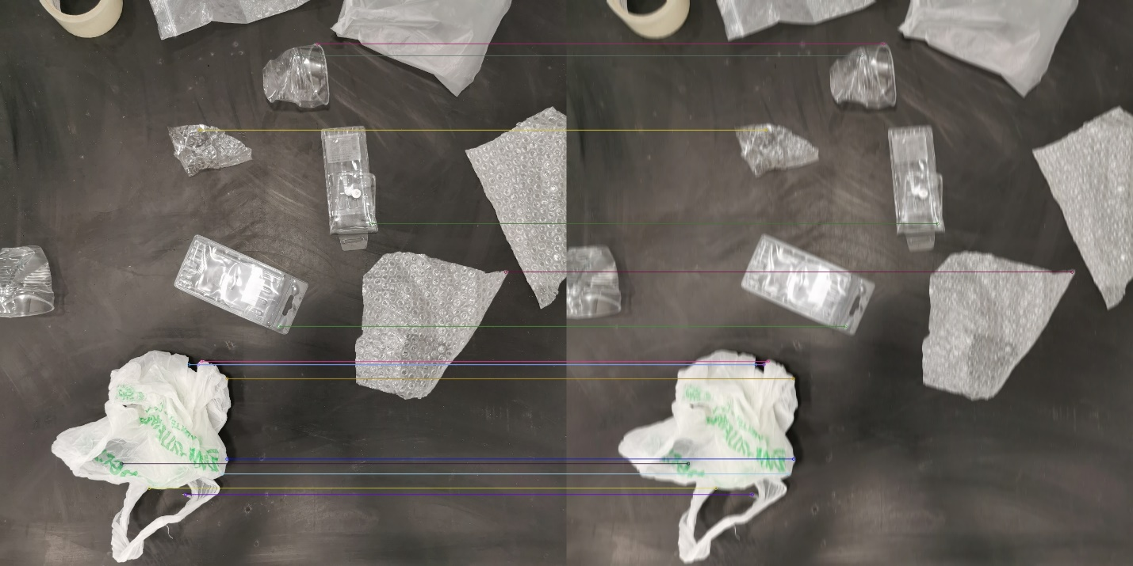

**Brute-Force Matching with SHIFT Descriptors and Ratio Test ( < 0.25*n.distance)**

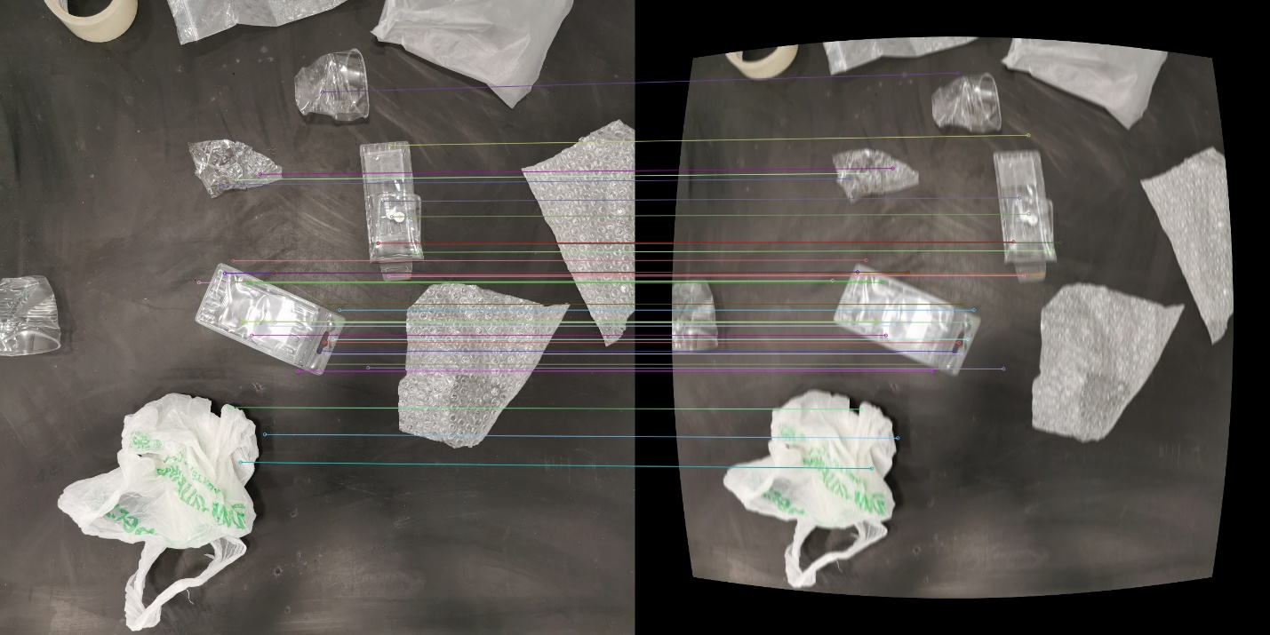

Total Keypoints: 879

Total Keypoints original image: 3879

Total Keypoints after sorting: 38